Customer NameDocument Title

INTERNAL
: Resorts World at Sentosa Pte. Ltd.

RWS
TECHNICAL SPECIFICATION – INTERFACE

S2P-I-018 TS for Exchange Rate Interface

Contents
1 Document Organization 5
1.0 Document Log 5
1.1 Integration, Document Reference 5
2 Clean Core Compliance 6
3 Program Attributes 6
3.1 Selection Parameter / Filter 7
3.2 Validation 7
3.2.1 Selection Criteria validations 7
3.2.2 Interface parameter validations 7
3.2.3 Other validations 7
3.3 Authorization Requirements 8
3.4 Definition 8
3.5 Defined Fields 8
3.6 Procedure 8
3.7 Technical Flow Diagram 8
3.8 Processing Logic 8
3.8.1 Validation 8
3.8.2 Mapping 8
3.8.3 Error Handling 8
3.8.4 Custom DDIC Objects 8
3.8.5 Custom CDS View Entity Details 8
3.8.6 BRF+ Design 9
3.9 Reusable Code 9
3.10 File Attributes 9
3.11 Internal Tables 9
3.12 Messages 10
3.13 Selection Text 10
3.14 Text Elements 10
3.15 Subroutines 10
4 Interface List Output 11
4.1 Field Details 11
4.2 Layout 11
4.3 Interface List Header & Footer 11
5 Application logs/Monitoring 11
6 Assumptions in Technical Design 11
7 Open Issues in Technical Design 11
8 Unit Test Results 11
9 Related Documentation 11

Document Organization
This section provides details about this document, previous version(s) of this document and the document(s) referred.

Document Log
Following table mentions the version changes and the processer(s):
Version | Status | Date | Version Created by (Name/E-Mail/Company) | Role | Comments
1.0 | Draft | June 24, 2025 | Ridhima Aggarwal | Author | Initial Draft
 | Choose an item. | Click here to enter a date. |  | Choose an item.

Integration, Document Reference
N/A
S. No. | Referred Document Name | Referred Document Version | Referred Document URL (Optional)

Clean Core Compliance
N/A
Final Solution | Category | Comments
 | Choose an item.

Program Attributes
Program title | Contract syncing from CSMS to S/4HANA
Program Name | ZGW_MM_CONTRACT_CSMS
Program Type | ODATA API
Package | ZMM
Authorization Group
Type of Interface | Synchronous
Mode of Execution | Online

Transaction Code
Include Programs
Function Modules
Message Class

Classes
Generic Classes / Utility Classes
AMDP Classes
Proxy Class
FEH action class
Basic IDoc type
IDoc extension
Custom IDoc segment(s)
AIF Function module
API Name
CDS Name
Behavior Definition
Behavior Implementation Class
Service Definition
Service Binding

Selection Parameter / Filter
N/A
Single Valued / Range | Mandatory | Value Help | Default Value | User Text

Validation
N/A

Selection Criteria validations

Interface parameter validations

Other validations

Authorization Requirements
N/A

Definition
The purpose of this document is to Send Currency exchange rate information to eCSS / CSMS system via API call.
This document will provide / guide us on the Data mapping of tables and fields for the development and implementation processes to and to ensure the system meets the business requirements and integrates seamlessly with the existing workflows.

Defined Fields
N/A

Procedure
- CSMS System will make and API call by sending the contract details to CPI.
- CPI will pass the data to S4HANA by calling ODATA : ZGW_MM_CONTRACT_CSMS
- Contract will be validated and created by using BAPI : BAPI_CONTRACT_CREATE BAPI_CONTRACT_CHANGE
- Generated Document number will be sent back to CPI.
- CPI will send the details to CSMS.

Techincal Flow Diagram
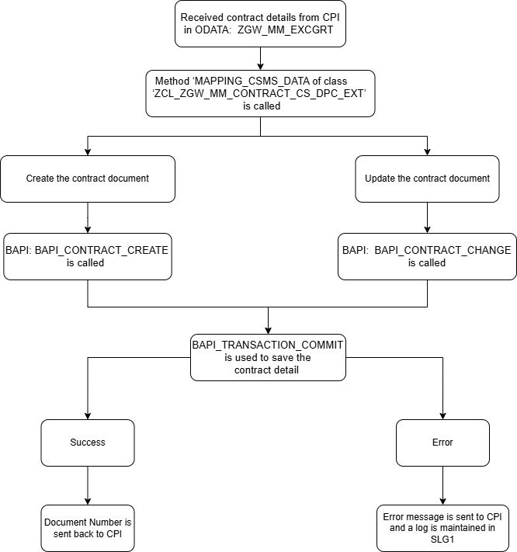

Processing Logic

ODATA ZGW_MM_EXCGRT will be called and validate through bapi BAPI_CONTRACT_CREATE BAPI_CONTRACT_CHANGE
.
- Below Entities are created for mentioned ODATA:
Contract ITEM
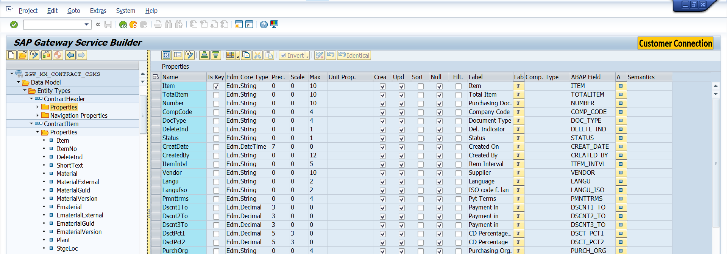
CONTRACTHEADER
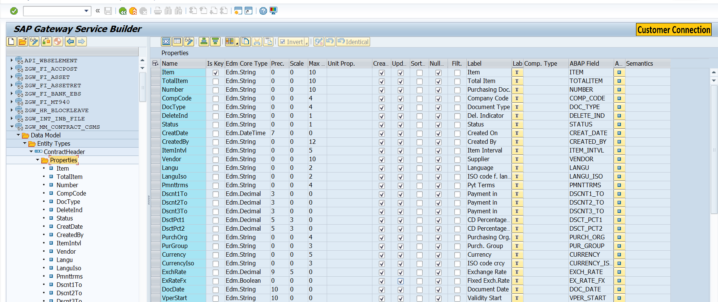

- Header Entity is mapped with Item Entity using Association: HeaderToItem

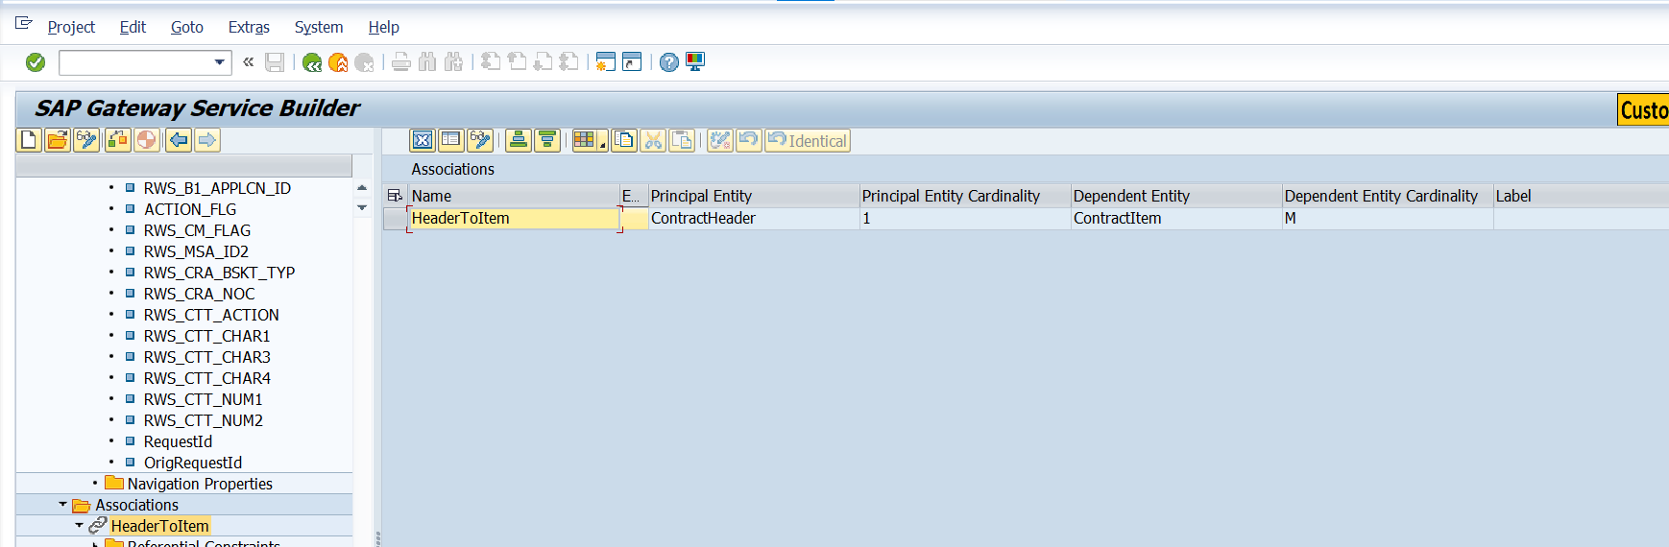

- Method ‘MAPPING_CSMS_DATA’ of class ‘ZCL_ZGW_MM_CONTRACT_CS_DPC_EXT’ will be called, which will contain the data mapped using mentioned entities.
- To determine whether the contract document to be updated or create CPI will send the value A for create and U for update in parameter ACTION_FLG of Contract Item entity.
- To create the contract document BAPI - BAPI_CONTRACT_CREATE is used and to update the existing contract BAPI_CONTRACT_CHANGE is used.
- BAPI_TRANSACTION_COMMIT is used to save the contract detail in S4HANA.
- If Document is successfully created or updated then the success message along with document number will be sent back CPI using method ‘COPY_DATA_TO_REF’.
- If error occurs while generating the document then pass the error message to CPI and log will be maintained in SLG1 by creating the object ZMM_CSMS and passing the object in FM ‘BAPI_LOG_CREATE’ and error message using FM ‘BAPI_LOG_MSG_ADD’.

Validation
N/A

Mapping
N/A

Error Handling
N/A

Custom DDIC Objects
N/A

Custom CDS View Entity Details
N/A
Custom CDS entity Name
Primary View
Associated Views

BRF+ Design
N/A

Reusable Code
N/A

File Attributes
Same details mentioned in corresponding CPI Document.
File Type | Excel, ASCII, etc.?
Delimited / Fixed width | Comma, tab?
Header Record? | Provide layout
Footer Record? | Provide layout
Number of File Layouts and Description
File Layout(s) | Complete one per file layout (i.e., one for header records and one for detail records):

Messages
N/A
Message Class | Message ID | Message Text

Selection Text
N/A
Name | Description

Text Elements
N/A
Name | Text Description

Subroutines
N/A
Name | Description

Interface List Output

Field Details
N/A

Layout
N/A

Interface List Header & Footer
N/A

Application logs/Monitoring
N/A

Assumptions in Technical Design
N/A

Open Issues in Technical Design
N/A

Unit Test Results
N/A
Scenario # | Input Selection Criteria | Expected Result | Actual Test Pass/Fail
 |  |  | Choose an item.
 |  |  | Choose an item.
 |  |  | Choose an item.

Related Documentation
N/A

Template Version

Version | Status | Date | Version Created by | Reviewer | Approver | Comments
1.0 | Final | February 11, 2019 | Abhishek Nayak | Jagmeet Singh | Modak Gupta | Initial version created
2.0 | Final | Oct 18, 2023 | Ravish Ranka | Jagmeet Singh | Modak Gupta | Updates according to latest development guideline

